**WEB ENGINEERING**

Project Report On:

***ONLINE ENGINEERING CONNECT***

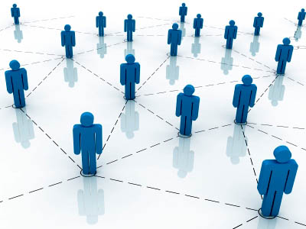

` By

Vaibhav Shah – RM2009057

Umang Sanghavi – RM2009049

Puja Sawant – RM2009050

Guided By:-

**Prof. Ajay Arunachalam**

**Prof. Rahul Shukla**



Department of Computer Engineering

D.J. Sanghvi College of Engineering

Mumbai University Academic Year: 2011-2012

CERTIFICATE

**This is to certify that**,

____________________________________________________________________________________________________

**Roll Nos:**

____________________________________________________________________________________________________

Studying in the third year of engineering in the computer department have successfully completed the project of Web-Engineering under the guidance of **Prof (Mr) Ajay Arunachalam** and **Prof (Mr) Rahul Shukla.**

**The Project topic is:**

____________________________________________________________________________________________________

**Subject in charge:**

***Date:***

**Abstract**

The Engineering Connect is an online portal for the whole engineering crowd. This web application provides complete information about the M.U affiliated colleges regarding their festivals, upcoming events and workshops etc and also gives a platform for both sides to interact with each other.

Our website aims at reducing the tiresome efforts of the students of different colleges to get information about different colleges pertaining to their festivals, admission procedure and in short whatever they require. So by using this website you will get information about each and every college on a single domain. It also provides a platform for the students to interact with other students, share their experiences, ask doubts etc.

The scope of the web application is global. It would be accessible from anywhere in the world where internet is available. This web application is designed to provide accessibility to the M.U students allowing them to gain information about the latest news of different colleges. The product is platform independent and the website is accessible on a slow network. This website is extremely easy to use and requires no user manual.

Users are provided with their respective password and login names. Henceforth they can proceed to the forum section. All the M.U university papers, FAQ’s and snapshots of respective college festivals are readily available on our website portal.

The Engineering Connect is a web service, which will allow authenticated users to view the inventories. PHP language is used to develop the web service, as it allows for easy, user-friendly functions, and integrating large databases is easy. MySQL is used to construct the database.

The following functionalities provided by us are summarized below:

* Easy interactivity by the web portal
* User friendly
* Educational and informative website
* Forum platform
* Latest news of various colleges
* University papers and time tables readily available

**Acknowledgement**

No project is ever complete without the guidance of those experts who have already tried this path before and have become masters of it. So we would like to take this opportunity with great pleasure to express our indebtedness towards all the people who have in various ways, helped in the successful completion of our project “**ONLINE ENGINEERING CONNECT**”.

We would like to owe our sincere gratitude to our project guide **Prof. Ajay Arunachalam** and **Prof. Rahul Shukla** for their support, guidance and co-ordination. We convey our gratefulness to them for being a constant source of inspiration and helping us in preparing the project, personally correcting our work and providing encouragement throughout the project. They have also provided us with the structure and the inventory database.

We shall be obliged to get response about the further improvements and suggestions expected by the user and also about any technical problems faced by them.

We extend our sincere appreciation to all our Professors from *D. J. SANGHVI COLLEGE OF ENGINEERING* for their valuable insights and tips during the designing of the projects. We are also grateful to our **Principal Dr. Hari Vasudevan** and **H.O.D. Narendra Shekokar** for extending his help through various channels in our Project work. We also thank the staff members and our colleagues for their co-operation.

***VAIBHAV SHAH***

***UMANG SANGHAVI***

***PUJA SAWANT***

**Conclusion and Future Scope**

Our web portal is designed to serve a purpose i.e. connect all the engineering students. Students from respective colleges will get a chance to know about different college’s students, festivals and also will get a platform to share his thoughts.

Our future plan is to make this website universally accepted i.e. an official common website for all M.U students so that students get all the updates regarding each and every college affiliated to Mumbai University. We are also planning to make it more user friendly i.e. the student can register to the upcoming events/seminars of any college using our website. We will also like to add a blog section so that professors, placements officers can get a platform to share their experiences and views about various things.

The scope of our website is global. It is user friendly and students can interact with different college’s students, can seek information about different college’s ongoing events and also post his views.

**TABLE OF CONTENTS**

1. **Problem Definition**
2. **Software Requirement Specification**
3. **Modelling Diagrams**

* **Use Case Diagram**
* **Activity Diagram** 
  + - * + Login page
* Admin
* **Sequence Diagram**
  + - * + Login page

1. **Code and Snapshots**
2. **References**

**Problem Definition**

Every college under Mumbai University has its own website where the college posts information about the upcoming events. But is there a website which unifies them all presenting information regarding all the colleges? Thus we felt a need for it and hence we have tried to connect all the colleges under one single domain.

This will not only be advantageous for the students but also for the college authorities. They can now upload whatever they find it to be important and thus can reach to all the students very easily and conveniently. Thus both the parties will benefit from this web application. Moreso there is also a forum for students to interact with each other.

Only one member will have the administrative rights having the username and password for one particular college, to handle it and also to upload the right information at the right time. Moreover it being online, it can be accessible from any remote locations.

***Engineering Connect***

Software Requirement Specifications:-

Literature Survey:-

In the recent times, website development has been of great importance. Websites have become imperative in this world of stifling competition. Thus the engineering arena has also jumped into the website marketing bandwagon. Hence, it becomes absolutely necessary to design, develop and maintain a website in such a manner that is lucid in its format and self-explanatory in its content.

Purpose:-

The idea behind the website Enginnering Connect – out-an-out engineering information website is to facilitate the acquisition of information about the engineering colleges under Mumbai University. It is a website for the entire engineering crowd. It will serve as information medium to all the students and even the colleges will get a platform to give details about their college festivals and interact with common students.

Scope:-

The scope of the website is global i.e. it can be accessed by all the people around the globe which want to acquire information about colleges coming under Mumbai University and help them plan and enjoy the festivals and workshops happening in colleges of Mumbai University.

Product Overview:-

Product Perspective:-

This particular website provides information about the respective colleges under M.U with their particular web sites directly linked also. It also gives a gallery of all the colleges and also gives university papers on a single click. All the frequently asked questions are contained in it. And the most important part of the website is the forum where everyone can interact with each other and share information about their respective colleges and experiences.

**System interfaces:-**

1. Software interfaces:-

* Database: MySQL server.
* Languages Used: HTML, CSS, JavaScript, PHP.
* Operating System: it can be any version of Windows OS, Mac OS.
* Browser Support: Mozilla Firefox, Chrome, Internet Explorer, Opera etc. Internet Explorer does not support some CSS features.

1. Hardware Interfaces:-

Server-Side:-

Processor: Pentium IV with 3.0 GHz or higher.

RAM: 2 GB or more

Hard drive: 80GB or more.

Client Side:-

Processor: Pentium III or higher with 2.0 GHz or higher.

RAM: 256 MB or more.

1. Communication Interfaces:-

The Communication interface is a local area network through wired routers or wireless routers.

Feasibility:-

1. Technical Feasibility:-

The website can be accessed on the World Wide Web and the URL is [www.engineeringconnect.co.in](http://www.engineeringconnect.co.in) .

1. Financial Feasibility:-

The website is very user-friendly and easy to use and also requires less finance for its maintenance. It also has the potential for revenue generation which can be realized by integrating various website monetization techniques.

.

**Modelling Diagrams**

USe Case Diagram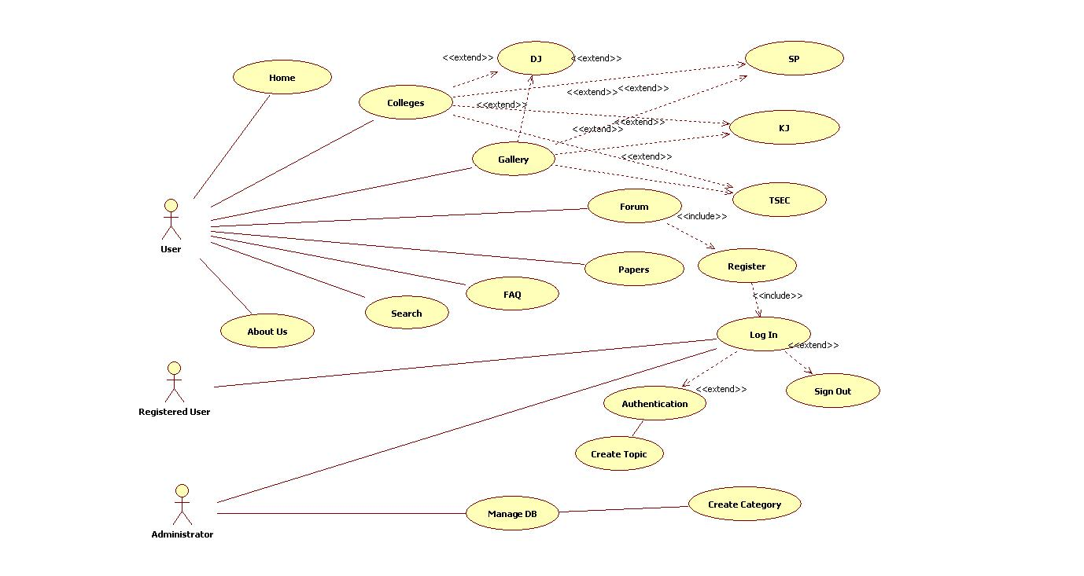

**ACTIVITY DIAGRAM FOR LOGIN**

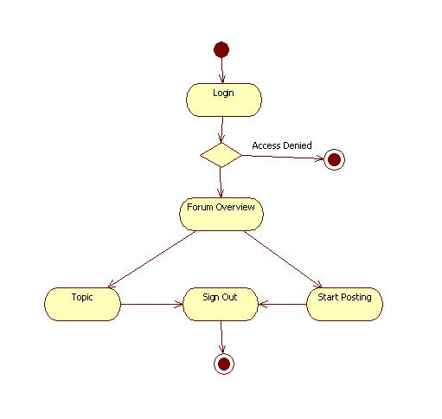

**ACTIVITY DIAGRAM FOR ADMIN**

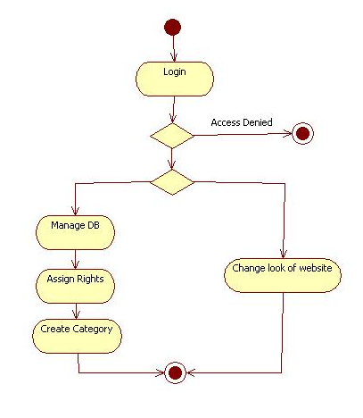

**Sequence Diagram for Login**

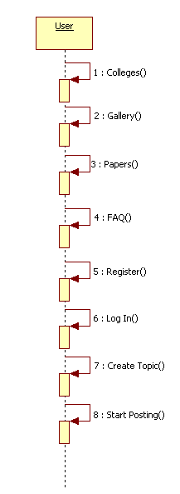

**References**

* http://www.zend.com/en
* http://www.w3schools.com
* www.stupidsid.com
* http://www.pixel2life.com/tutorials/php_coding